Spring into Yosemite National Park
Arriba! Ski and Snowboard Club
June 8 through 12, 2019
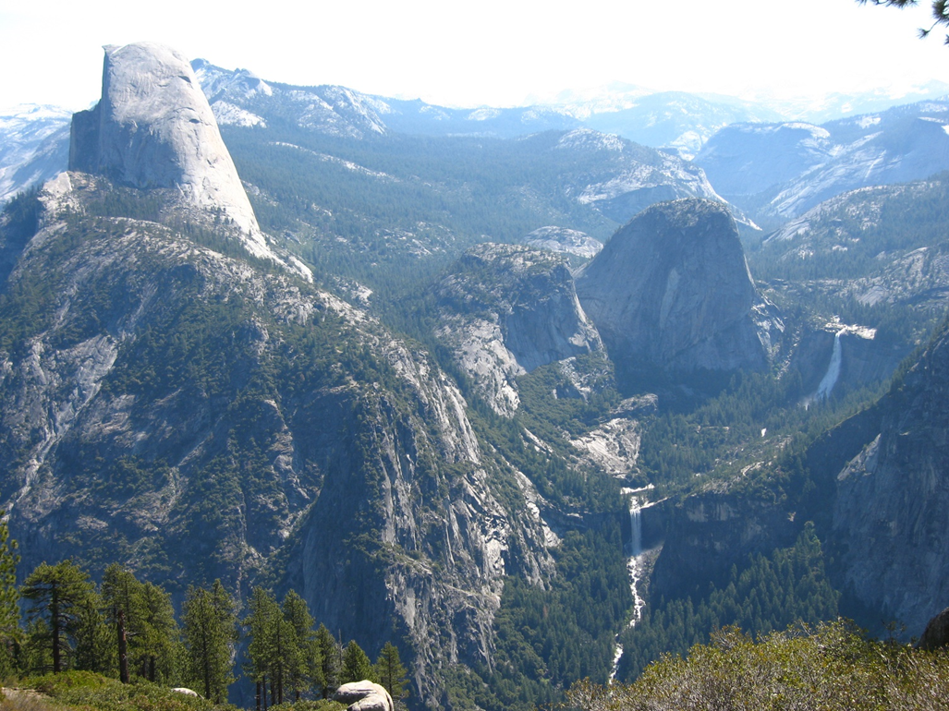

Arriba! announces the Yosemite National Park trip for 2019. This late spring season trip is a long standing tradition for the Club, and in conjunction with the membership survey preferences, several changes have been made. This year’s trip will be 4 days to allow sufficient time to experience the many activities and hiking experiences Yosemite has to offer. June is high peak season. So to help avoid at least some of the weekend crowding, the trip this year spans a Saturday arrival to a Wednesday departure with the Saturday night accommodation outside of the Park at Tenaya Lodge near the Park’s south entrance. The trip dates this year are June 8 Saturday through June 12 Wednesday.

Although officially the 2018 season has been yet another drought year we are hopeful for a good snow pack this year. In any event, next June will still be the best opportunity for viewing and hiking the major waterfalls in the park. The opening of Tioga Pass and access to the high country attractions of Yosemite will be dependent on the level of snowpack that is received this season.

Because it is very difficult to secure a reservation in the high tourist season, the Club contracted with the Yosemite Groups department in early 2018 to reserve a block of rooms for us. This is a very significant cash commitment and the Yosemite Group cancelation policies are rigid.

The planned itinerary is as follows:
- 8-Jun Saturday – depart by your own vehicle to south Yosemite. Approximately a 4 ½ hr drive to the South Entrance (Hwy 41).
- Accommodation for 1 night at the Tenaya Lodge at Fish Camp about 2-3 miles from Yosemite’s south entrance. Rooms are double occupancy. Check In time is 4:00pm. We have secured a contract price that includes the resort fee (WiFi, pool access, etc.), parking for one vehicle and all taxes.
- 9-Jun Sunday – check-out and transfer to Yosemite Valley for 3 night’s accommodation at Yosemite Lodge. Rooms are double occupancy.
- 12-Jun Wednesday – check out from Yosemite Lodge and return to LA at your leisure. Check out time is 11:00am

Tenaya Lodge

The deluxe Lodge rooms are equipped with 2 queen size beds. A limited number of king bed rooms may be available. Amenities include a fitness center, electric vehicle charging stations, indoor and outdoor pools (weather permitting) and game room.

Dining choices include the Sierra Restaurant ($$-$$$), Jackalopes Bar and Grill ($$), Embers Dining Room ($$$+), a pizzeria, and a deli style takeout.

The resort can arrange activities for additional charge such as archery class, mountain bike tours, and steam train rides.

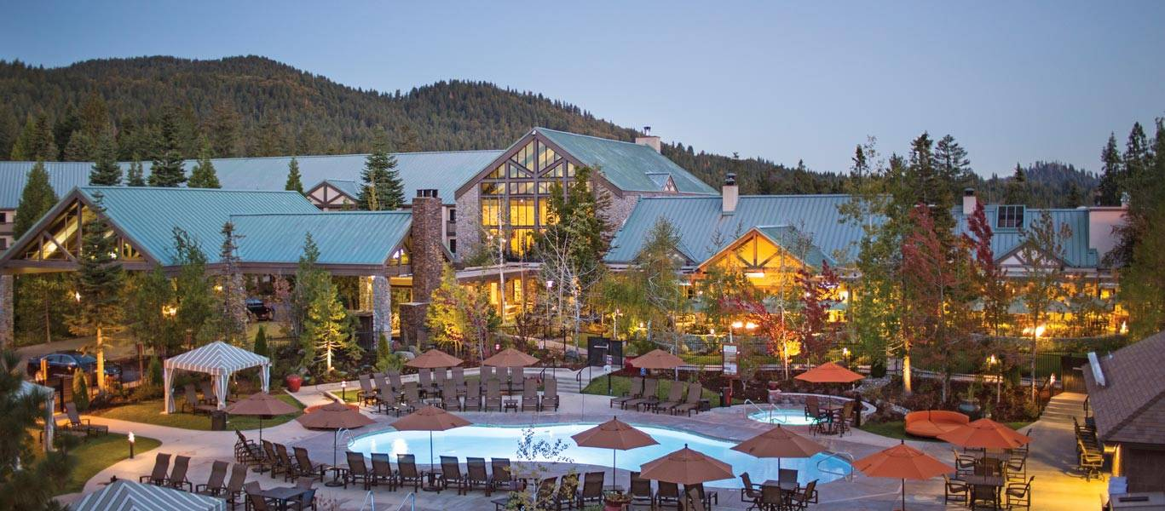

The Mariposa Grove of giant Sequoia trees is nearby at the South Entrance of the Park. The Grove is now pedestrian only. There is a free shuttle bus from the Park South Entrance with a limited parking area of about 300 spaces.

The Wawona area facilities include a 9-hole golf course situated in an alpine meadow (advance booking required), equestrian stables (advance booking required), a dining room for lunch or dinner, and main lodge parlor room for cocktails.

The South Fork of the Merced River flows through the area.

Other points of interest on the way to Yosemite Valley include Glacier Point for spectacular views of the Sierra Nevada, and easy hikes to Sentinel Dome and Taft Point.

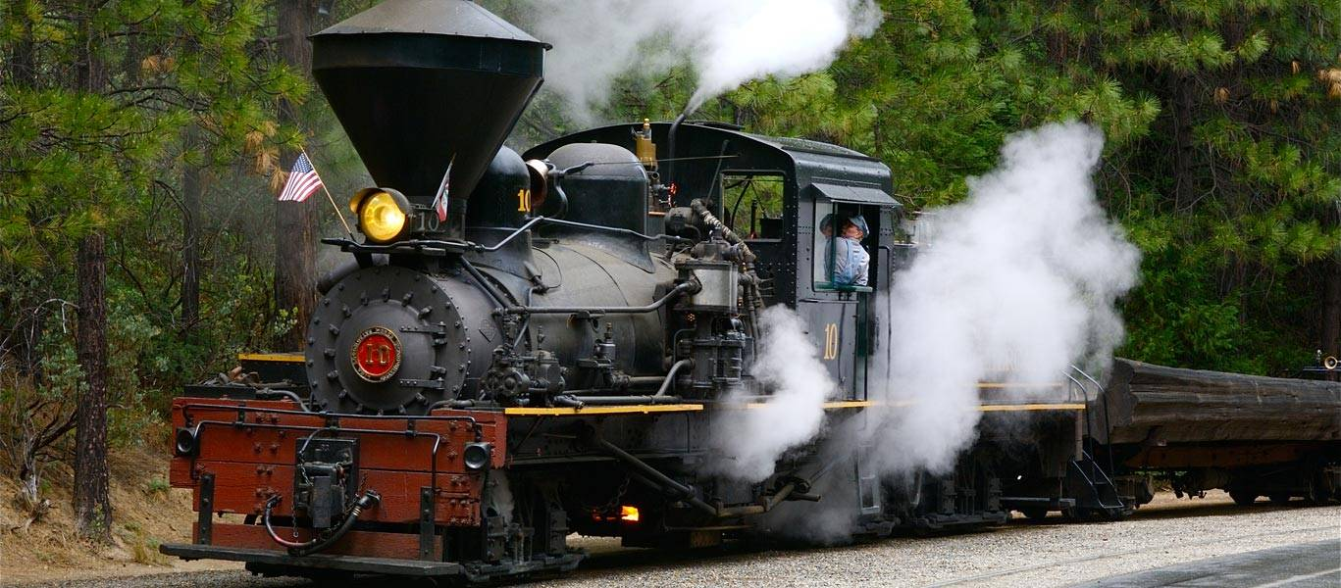

Take a ride on the Sugar Pine steam train located near Tenaya Lodge. Shay locomotives were originally used for logging operations.

Yosemite Valley Lodge

Yosemite Lodge is the largest of the three accommodation properties located within Yosemite Valley itself. It is located very near the base of Yosemite Fall.

The center complex consists of the Main Lodge, cafeteria and Starbucks coffee house, full size swimming pool, bike rentals, gift and supply shop, the Mountain Room restaurant ($$-$$$), and a separate bar also serving pub style food.

A free Valley shuttle bus system allows transportation to points of interest without having to move or re-park your car.
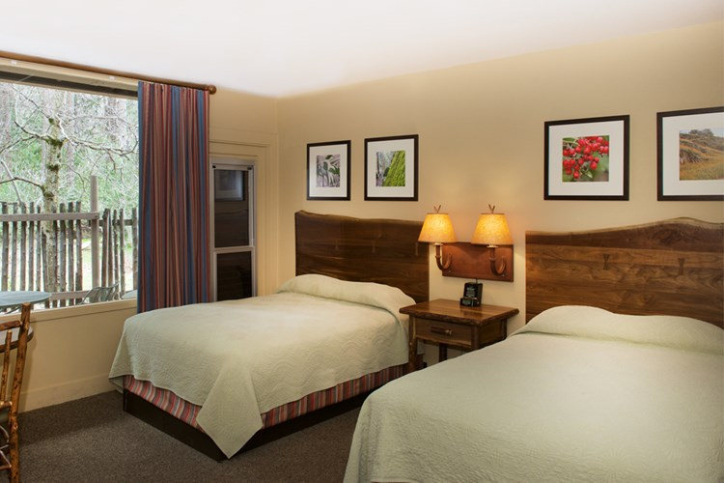

A Yosemite Lodge standard 2 bed room with outdoor patio area. Upstairs rooms have a balcony sitting area.

Trip Pricing
- Price per person (double occupancy) $705.00 before March 1
- Price per person (double occupancy) $775.00 after March 1

What’s Included:
- 4 night’s accommodation at the properties described above
- Property Parking permit – only 1 vehicle per room
- The Club will provide snacks and beverages for a nightly ‘Happy Hour’ social gathering

What’s Not Included:
- Your own transportation
- There is a Park entrance fee of currently $35 per vehicle valid for 7 days and includes ‘in and out’ privileges in case you want to go outside the Park during that period.
- A credit card is required per room for a security deposit and you are responsible for any incidental room charges
- Meals are not included in the trip cost
- Any Park activity or tour fees

Payment Policy:
- Your space is Not Confirmed until your payment is received. Individual Priority will be given by the Date and Time your payment is actually received.

Payment Methods:
- PayPal – use the website www.arribaski.org and link to the Payments page and select the Yosemite trip.
- Payment by check payable to Arriba Ski Club and mailed to
P.O. Box 69611
West Hollywood, CA. 90069-0611
If paying by check, please notify me ASAP by email of your check number and the date you mailed it so I can be sure to hold your space.
- For any questions, contact me by email at vinney69@gmail.com or by telephone 310.376.1916 and I will get back to you as soon as I can.

Cancelation Policy:
- Cancelations before April 24, 2019 subject to a $25 cancelation fee
- Cancelation after April 24, 2019 may forfeit any amounts paid unless the space can be resold and then subject to the $25 fee. (If the trip is initially sold-out, a wait list will be maintained)

Optional Dinner at the Majestic Yosemite Hotel (formerly the Ahwahnee Hotel)

Another Club tradition on the Yosemite trip has been to have a group dinner in the grand dining hall of the Ahwahnee Hotel. Please indicate when you sign-up if you would like to be included in this option. The Cost for the dinner is not included in the trip and is your responsibility. Depending on your choices for starter, entrée, and drinks, the cost could be around $100 or more. Please consider this and the need to be flexible on the seating time due to the popularity of this historic hotel.

The actual date and time is dependent on availability and how many people are interested in attending.

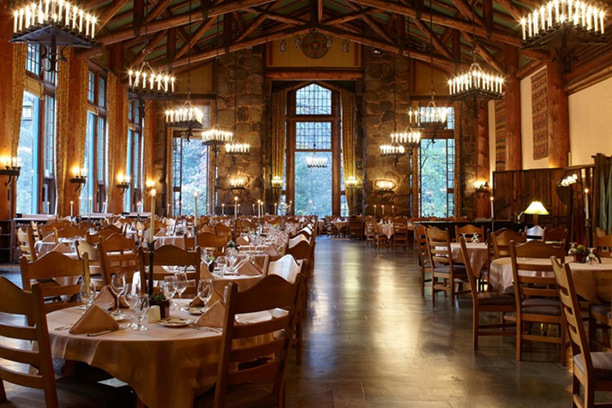

The Ahwahnee Grand Dining Hall
