JAPAN
February 6th- 19th, 2017
Back by popular demand
Arriba heads back to the land of the Rising Sun

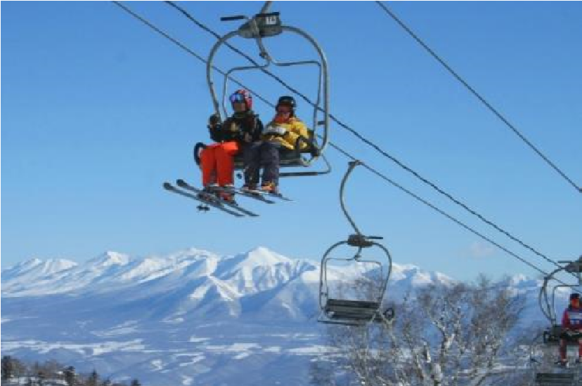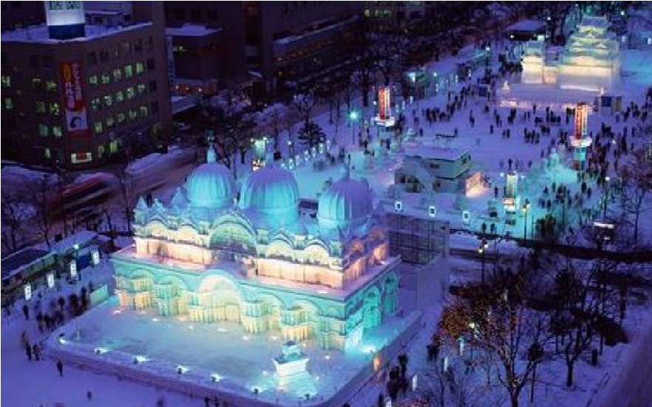
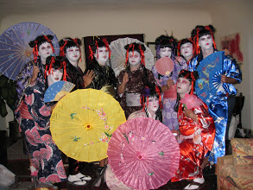

This trip is going to be epic- Art, Culture, Epicurean delights, and of course skiing and snowboarding galore!

We will be starting out in Sapporo- home of the famous beer and host of the 1972 Winter Olympics.

Japan is a land of contrast and diversity. While this itinerary covers major sightseeing spots definitely worth visiting, it also integrates lesser-known hidden gems of Japan. Enjoy the alluring diversity- traditional and modern culture of Japan, energetic big city and peaceful rural areas, and historical sites. Also, you will experience world-class powdery snow of Hokkaido, and Sapporo Snow Festival. On this itinerary, you will travel to Sapporo, Otaru, Furano, Takayama, Gokayama, Shirakawago, Kanazawa and Tokyo.

Sapporo/Furano/Takayama/Kanazawa/Tokyo- 12 nights
Monday February 6 to Sunday February 19, 2016 (Outgoing flight leaves late Sunday Feb 5)
PRICING FOR GROUP ECONOMY AIR, LODGING, GROUND TRANSPORTATION AND TRANSFERS (Airfare based on minimum 10 people signing up. Land package may also be adjusted if not enough people sign up for trip)

- Early Bird Sign–up by September 23 $5600 per person ($500 Savings)
- Standard Sign-up by November 1 $6100 per person
- Single room Supplement 12 nights Add $1100
- NO AIR Deduct $1000
*Please note that if you deduct air, you will be responsible to arrange for own internal CTS-NGO flight
Optional Tours:
- Backcountry Tour: $280
- Tokyo City Tour: Price to be determined based on number of people who sign up

Payment and Sign-Up Schedule:
Either email Sign-Up sheet to Moises Cruz, OR, mail Sign-Up sheet to the Attention of: Out-Of-State Trips to the Arriba address listed below by the required dates.

Early Bird Payment Schedule
September 23rd a deposit of $1600 is due.
November 1st a payment of $2,000 is due.
December 1st the trip balance is due.

Standard Sign-Up Payment Schedule
November 1st a deposit of $2,000 is due.
December 1st a payment of $2,000 is due.
January 1st the trip balance is due.

Information on Travel Insurance to follow

Air Itinerary on All Nippon Airlines (ANA):​

1 NH 105​ ​06FEB ​ ​LAX​－​HND​ ​ ​ ​00​:​05 05​:​05 ​(​07FEB​)
2 NH ​ ​51​ ​07FEB HND​－​CTS ​ ​ ​ ​07​:​00 08​:​30
3 NH 706​ ​13FEB ​ ​CTS​－​NGO 12​:​05 14​:​00
4 NH ​ ​ 6​ ​19FEB ​ ​NRT​－​LAX ​ ​17​:​05 0​​9​:​50

February 6th, Monday | Fly to CTS/Sapporo

Fly from LA to CTS/Sapporo

February 7th, Tuesday | Arrive at CTS

Arrive at CTS/Sapporo. Meet your guide (Hitomi- who is amazing! She was our guide on the last Japan trip) at the airport gate. Private transfer to your hotel in Sapporo city by bus.

Accommodation: Ibis Styles Sapporo (2 nights) Room type: Twin or King/Queen (30 square metres) Meals: Breakfast
Ibis Styles Sapporo is a superior-class hotel conveniently located in Susukino, the largest entertainment district in Hokkaido. Enjoy contemporary atmosphere with comfortable amenities.
The main snow festival site called Odori Park is conveniently located within a 15 minute walk.

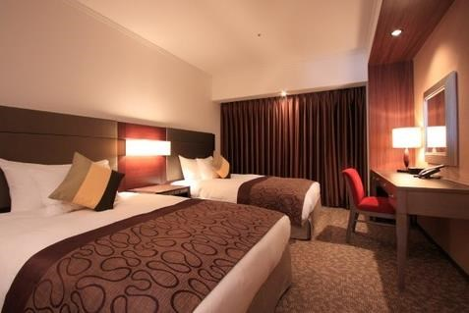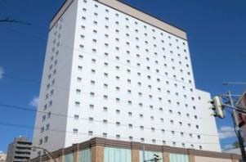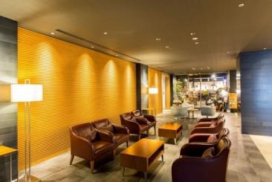

February 8th, Wednesday | Sapporo Tour

9:00 Meet your guide in the hotel lobby. Tour by private bus.

You will be escorted to 3 sites of Sapporo Snow Festival. In Tsudome site which is located in outer area of Sapporo, visitors can enjoy a variety of fun activities such as sliding on the huge slopes, snow raft, zipline, snow park golf, snow ball competition, etc. There will be snack stands which can be recommended for your lunch (Lunch and activity fees are at your expense).

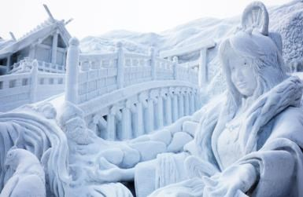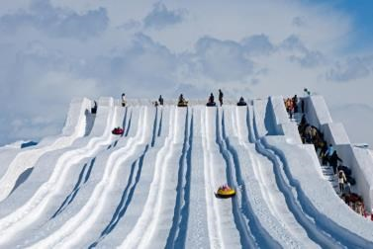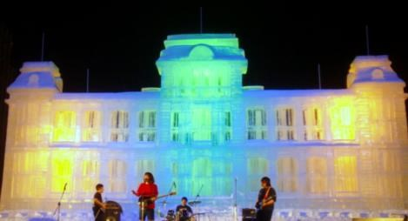
Move back to Sapporo city center. You will be escorted to Odori Park Site and Susukino site to see massive snow and ice buildings, ice carving competition, etc.

17:00 Arrive at your hotel (or you can continue exploring festival sites on your own)

Welcome dinner at local restaurant (casual)
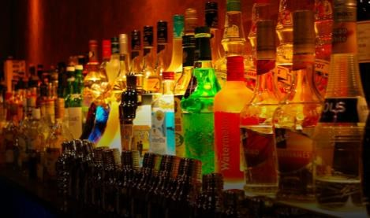

Nightlife in Susukino
Within walking distance from your hotel, you will find many bars in Susukino which is the largest entertainment district in Northern Japan. There is a small gay district in Sapporo city.

February 9th, Thursday | Sapporo – Otaru - Furano

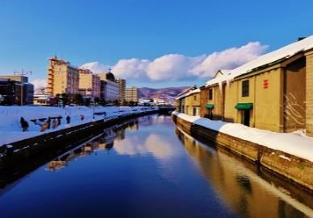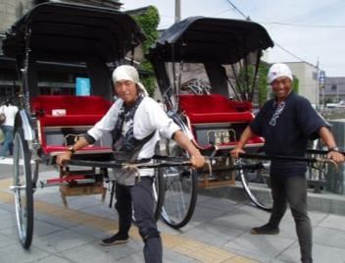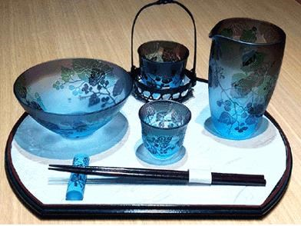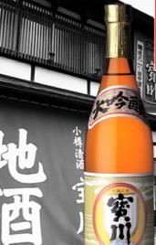

9:00 Meet your guide in the hotel lobby. Tour by private bus. Move to Otaru (approx. 1 hour). Otaru Canal used to be a central part of the city's busy harbor in the first half of the 20th century, when large vessels had to be unloaded by smaller ships, which then transported the goods to warehouses along the canal. Enjoy a short rickshaw ride (12 mins) to explore the picturesque area. Then, enjoy walking through the street with warehouses which were transformed into glassware shops, craft & souvenir shops, and café.
Also, visit a local sake brewery which has received many quality sake awards. Try freshly brewed sake as it is sake production season.
For your lunch, Otaru’s famous sushi will be arranged.
In the afternoon, move to Furano

Accommodation: Shin Furano Prince Hotel (4 nights) Room type: Standard twin room (26 square metres) Meals: Dinner (choice of buffet, Japanese set or Western set) and breakfast
Shin Furano Prince Hotel is probably the most popular hotel in Furano. World-class ski slopes locate just in front of this hotel. The hotel offers comfortable stay with modern amenities, and in the premise there are common hot spring baths separated by genders, shops and a small street lined with craft shops in the forest.

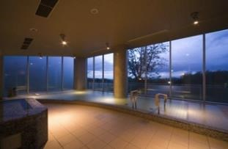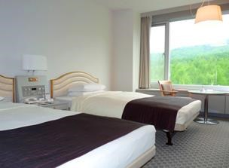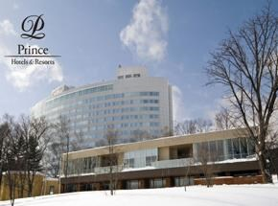

February 10th, Friday  February 11th, Saturday  February 12th, Sunday | Free Days in Furano- Skiing.  Back Country Guided Ski Tour in Mt. Asahi (Optional)

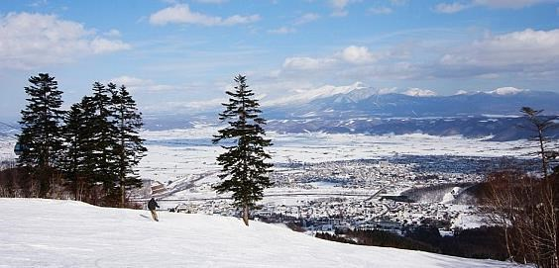
Furano is one of the most popular ski resorts amongst Japanese skiers. Thanks to the wind from Siberia, the area can receive the lightest and driest snow in Hokkaido. Skiers and snowboarders can enjoy quality powdery snow, a panoramic view of the Furano Valley and Tokachi Peak Mountain range. Several competitions have been held here, such as FIS Alpine Ski World Cup, and Snowboarding World Cup.

Rental equipment and lift pass can be arranged in the final stage.

February 13th, Monday | Move to Takayama

Move to Sapporo/CTS airport by private bus
Fly to Nagoya/NGO
Arrive at NGO. Move to Takayama by private bus

Accommodation: Hotel Associa Takayama Resort (2 nights) Room type: Standard Twin (35 square metres) Meals: Breakfast
Hotel Associa Takayama Resort is probably the best hotel in the city, offering comfortable stay. In the premise, there are Japanese and European restaurants, as well as cafés and a bar. Guests can enjoy common hot spring baths separated by genders, overlooking Takayama city and Japan Alps if the weather is clear.

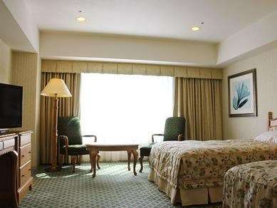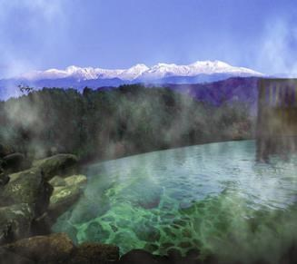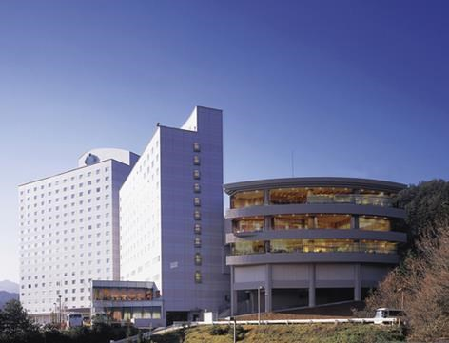

Standard room Common hot spring bath Hotel building

February 14th, Tuesday | Takayama & Okuhida Tour

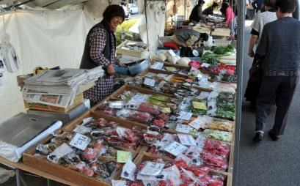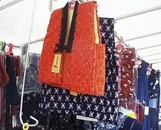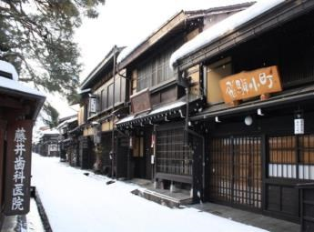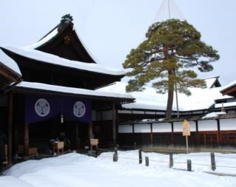

9:00 Meet your guide in the hotel lobby. Enjoy tour by private bus.

Takayama is a beautifully preserved small old town surrounded by Japan Alps. Just by walking along the narrow streets, lined with old private houses, sake breweries, and craftsman’s shops, you can feel the history of 300 years. You will be escorted to Old street, Jinya (The office where Samurai was located) and famous morning market. Lunch in the local eatery will be arranged.

Move to Okuhida area (approx. 1-1.5 hours).

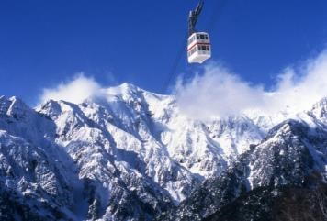
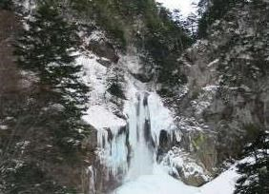
Enjoy gondola ride to the observation point of Japan Alps. Two gondolas will take you to the 2156 meter high, overlooking Northern Japan Alps such as Mt. Hodaka.

Hirayu Otaki is considered as the three largest waterfalls in Hida-Takayama area. The water fall is 64 metre high and it is nice to walk to the observation point.

Move to Takayama area (approx. 1.5 hours).

17:00 Arrive at your hotel in Takayama.

February 15th, Wednesday | Private Tour to Kanazawa via Shirakawago & Gokayama  Villages

9:00 Meet your English-speaking guide in the hotel lobby. Move to Shirakawago by private bus (approx. 1 hour).

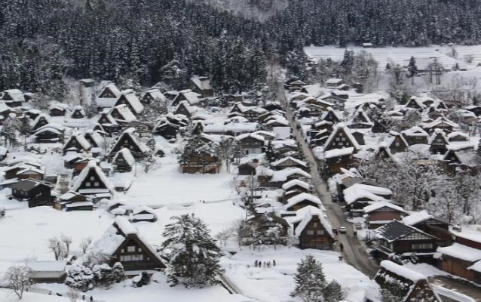
The thatch-roofed Gassho-style homes as well as unique traditional way of life, which have been preserved under severe natural environment, are valuable treasures Japan would like to hand down to future generations. Shirakawago is registered as world cultural heritage of UNESCO. Gassho means “praying hand”, which is the image of the steep roof of farmhouses.
Visit the Observatory, a popular spot offering a magnificent view of the whole village.

Move to Gokayama (approx. 1 hour).

Gokayama is a mountain village with Gassho-style homes and part of UNESCO World Heritage site along with Shirakawago. It is considered that the quality of traditional architecture in Gokayama is superior to the one in Shirakawago and many of the houses are more than 300 years old. The village is further country-side and you can experience authentic local culture by learning Gokayama’s lifestyle and culture remained very traditional.
Kokiriko, traditional folk dance will be performed at one of the historical thatch-roofed house in the village.
Also, the area is highly reputed for Gokayama Washi, Japanese paper designed as traditional craft by the Japanese government. Experience traditional paper making in traditional method. Paper crafts can be also purchased in the village.

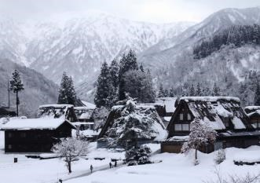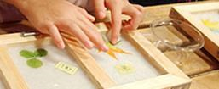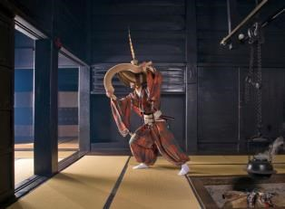

Country-style lunch will be arranged.

Move to Kanazawa (approx. 1 hour) Around 17:00, arrive at your hotel.

Accommodation: ANA Crowne Plaza Hotel Kanazawa (2 nights) Room type: Standard twin or King/Queen Meals: Breakfast
ANA Crowne Plaza Kanazawa is conveniently located in 1 min. walk from JR Kanazawa Station. The hotel offers comfortable stay with modern amenities. The hotel has a variety of restaurants such as European, Japanese, teppanyaki, Chinese, as well as lounge and bar.
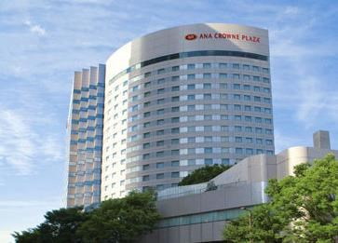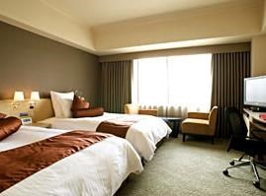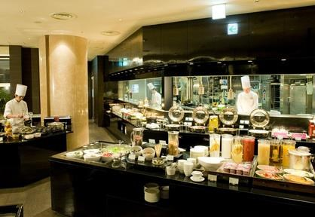

February 16th, Thursday | Kanazawa Tour

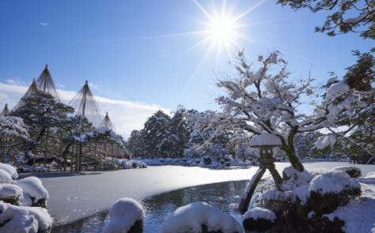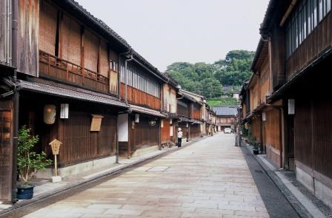

9:00 Meet an English-speaking guide at your hotel. Enjoy your private tour by private van.

Start at Kenrokuen Garden which is known as one of the best three gardens in Japan. A fountain created using the natural pressure of water flowing from the higher pond is a must-see.

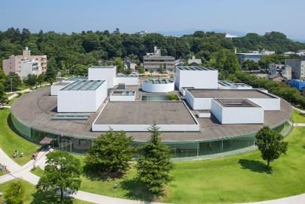
Then, visit 21st Century Museum of Contemporary Art, Kanazawa. This art museum is uniquely round-shaped and all the walls are made of glass which was designed by SANAA (Kazuyo Sejima & Ryue Nishizawa). The museum exhibits experiment-type contemporary arts that visitors can touch or sit on. The most popular masterpiece at the museum is “Swimming Pool” by Leandro Erlich, where you feel as if other guests are standing on the bottom of the pool.

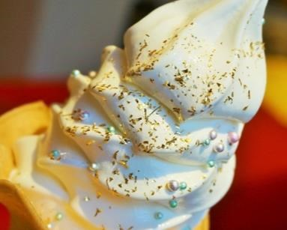
Visit a preserved area called Higashi Chaya District. Here is the biggest geisha district in Kanazawa, which is registered as cultural asset by the Japanese government. You will also visit one of the preserved chaya (geisha house) which is opened for public.

Kanazawa boasts gold leaf. You will be escorted to an established gold
leaf shop. If you would like, try soft ice cream with edible gold sprinkles (at your expense).

17:00 You will be escorted to your inn in the end of tour.

February 17th, Friday | Move to Tokyo by bullet train, and Free Afternoon in Tokyo

9:00, meet your guide in the hotel lobby. Get on a bullet train to Tokyo (approx. 2.5 hours, standard class reserved seats).

Arrive at Tokyo. Transfer to your hotel by vans.
Free afternoon in Tokyo.

Accommodation: Keio Plaza Hotel Shinjuku (2 nights) Room type: Standard Twin (23 square metres) Meals: Breakfast
Keio Plaza Hotel is located in Shinjuku which is one of the major shopping, dining and entertainment areas of Tokyo. Though the hotel is not in Shinjuku 2chome, it is still accessible within 5 minute taxi ride or 20 minute walk.
There are Japanese, French & Italian, Sushi & Tempura, Chinese, Korean, Buffet restaurants, bar and lounge in the hotel.

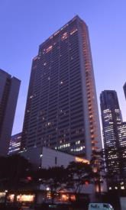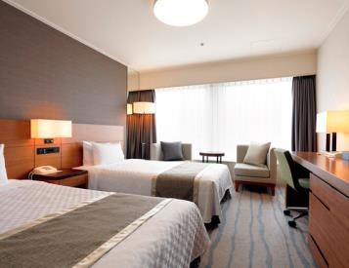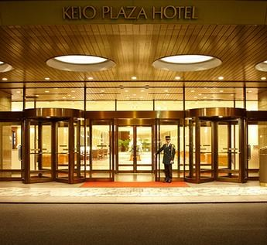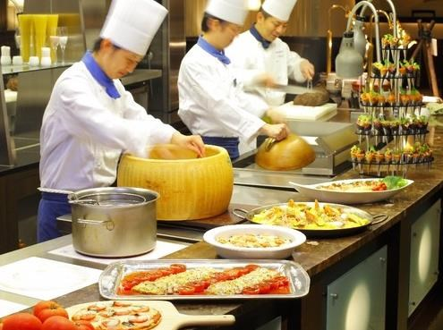
Exterior Standard twin Entrance Buffet restaurant

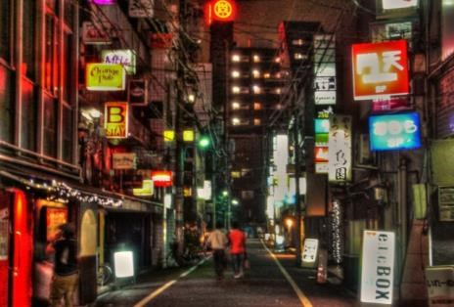

Nightlife in Shinjuku
Shinjuku is the largest entertainment district in Japan with many restaurants, café and bars. Shinjuku 2 chome is the largest gay town in Japan. We will give you directions, how to reach the district by walk from your hotel in the final stage.

February 18th, Saturday | Free Day in Tokyo

Enjoy free day in Tokyo.
Optional tour is available.

February 19th, Sunday | Fly out of NRT

Meet your guide in the hotel lobby. Private transfer to NRT by bus.
Have a safe flight

Optional Tour 1) | Backcountry Ski Tour in Mt. Asahi, February 10th
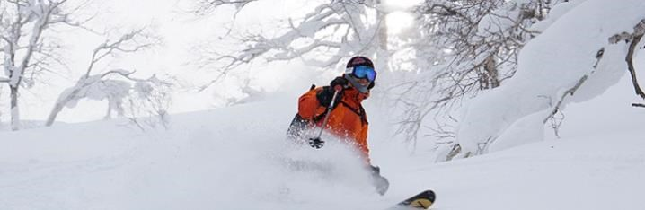

Experience backcountry skiing in Mt. Asahi (2,291 metres) of Taisetsu Mountain Range.

7:30am Meet your mountain guide (Easy English-speaking level) in the hotel lobby. Move to Mt. Asahi area by mini bus (approx. 1 -1.5 hours). Please bring your ski equipment.

9:00 Get on a gondola to Mt. Asahi. Enjoy backcountry skiing escorted by mountain guide. Lunch at your expense at the cafeteria of gondola station.

14:30 Return to the foot of Mt. Asahi. Leave for Furano.

Around 16:00 arrive at your hotel in the end of tour.

The number of guests per guide will be minimum 4, and up to 6. We are happy to arrange up to 2 guides for this activity.

 | Number of guests
Price per guest | $280

Minimum 4 guests, up to 6 guests

Price includes easy conversation level English-speaking mountain guide, insurance, gondola ride, mini bus between your hotel and Mt. Asahi, rental beacon, tax and service charge. Lunch/meals are at your expense.

Optional Tour 2) | Tokyo Walking Tour, February 18th

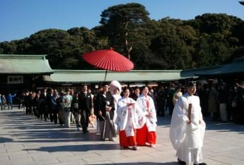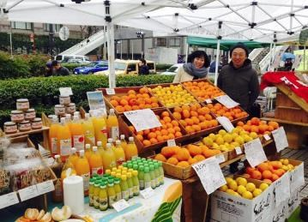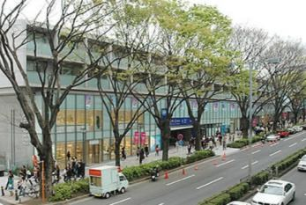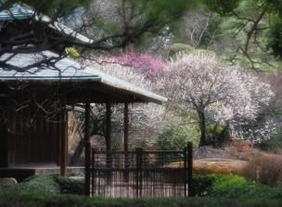
9:00
Meet

your guide in the hotel lobby. Enjoy private tour by taxis.

8:30 meet your English-speaking guide in the hotel lobby. Enjoy tour by local trains.

Start at Tsukiji Fish Market. The wholesale section has moved to Toyosu district in November 2016, visitors can still enjoy a variety of ingredients in Tsukiji. Not only fish and seafood, there are dried products, deli, marbled wagyu beef, as well as kitchen utensils.

Move to Ginza, the most sophisticated shopping district in Japan. Your guide will show you gourmet hall and popular boutiques such as traditional stationeries, craft, etc.

Lunch at a local Japanese eatery (included in the price).

Visit Imperial Palace. As it is royal family’s residence, visitors are not allowed to enter but it is nice to observe picturesque Nijubashi Bridges (Double Bridges). Also, you will be escorted to Imperial palace East Garden. Usually in the middle of February, fragrant plum flowers will be in bloom.

Move to Meiji Shrine, the most worshipped shrine in Japan which was built in 1920. Though it is located in Tokyo city centre, you will feel sacred atmosphere surrounded by pristine forest. Your guide will show you how to pray at the shrine. Also you might be able to encounter traditional wedding ceremony as it is weekend.

Walk through Omotesando, the most fashionable street in Japan.
You will find souvenirs, traditional and contemporary craft in the area. Also, your guide will show you some modern architecture designed by leading Japanese and international architects.

Take a glimpse of local lifestyle. You will be escorted to Weekend Farmers Market in Tokyo city centre. There are over 70 specialty vendors such as fresh vegetables, fruits, vinaigrette, jam, green tea, coffee, bread and more.

Return to your hotel by local trains.
17:00 end of tour at your hotel.

 | Number of guests
 | 5-7 | 8-10 | 11 and more
Price per guest | $175 | $140 | $130

Price includes English-speaking guide for 8.5 hours, local trains, casual lunch, tax and service charge.

